SYSC 4001 Assignment 2
Atik Mahmud (101318070) & Modibedi Mosigi (101256959)

Part I

a.
1i) FCFS is a scheduling algorithm used to allocate resources to processes in an operating system. How it works is that process enter the system and are placed in a ready queue in order of which process arrived first. The scheduler then allocates resources to the first process in the queue; the process then runs until completion with no interruptions. After the current process is completed, it terminated then the next process in the queue is allocated CPU resources.
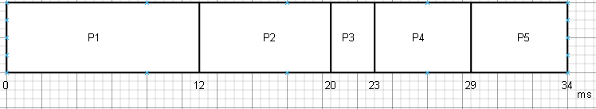

Process | Completion Time(ms) | Turnaround Time(ms)
P1 | 12 | 12 – 0 = 12
P2 | 20 | 20 – 5 = 15
P3 | 23 | 23 – 8 = 15
P4 | 29 | 29 – 15 = 14
P5 | 34 | 34 – 20 = 14

Mean turnaround time = (12 + 15 + 15 + 14 + 14) / 5 = 14ms

(ii) Round Robin (time slice of 4 ms)

When multiple processes are waiting for the CPU, the round robin algorithm ensures that each one receives an equal share of processing time. Each process is given a small unit of CPU time known as the time quantum, usually between 10 and 100 milliseconds. When a process finishes before the quantum expires, it leaves the queue. Otherwise, the process is preempted when the time runs out and placed at the back of the ready queue to wait for its next turn. A timer interrupt occurs at the end of each quantum to schedule the next process.

If there are n processes in the ready queue and the time quantum is q, then each process gets one-nth of the CPU time in chunks of at most q time units. This means that no process waits longer than (n - 1)q before it runs again. The algorithm continues cycling through the queue until all processes are complete, ensuring that every process gets repeated access to the CPU at regular intervals.

The length of the time quantum directly affects performance. If the quantum is too large, the behavior starts to resemble First Come First Served scheduling. If it is too small, the system spends too much time switching between processes, which increases overhead. Choosing the right quantum is important to balance fairness and efficiency. Round robin scheduling is most effective in time-sharing systems where equal opportunity and responsiveness matter more than raw throughput.

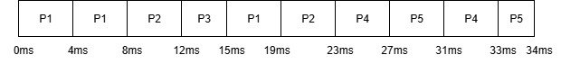

t = 0ms:
ready queue (front to back): P1
CPU goes to: P1

t = 4ms:
ready queue (front to back): P1
CPU goes to: P1

t = 8ms:
ready queue (front to back): P2, P3, P1
CPU goes to: P2

t = 12ms:
ready queue (front to back): P3, P1, P2
CPU goes to: P3

t = 15ms:
ready queue (front to back): P1, P2, P4
CPU goes to: P1

t = 19ms:
ready queue (front to back): P2, P4
CPU goes to: P2

t = 23ms:
ready queue (front to back): P4, P5
CPU goes to: P4

t = 27ms:
ready queue (front to back): P5, P4
CPU goes to: P5

t = 31ms:
ready queue (front to back): P4, P5
CPU goes to: P4

t = 33ms:
ready queue (front to back): P5
CPU goes to: P5
t = 34ms:
ready queue (front to back): — (empty)
CPU goes to: —
Program finishes.

Completion Times:
P1: 19ms
P2: 23ms
P3: 15ms
P4: 33ms
P5: 34ms

Turnaround Time:
P1: 19 – 0 = 19ms
P2: 23 – 5 = 18ms
P3: 15 – 8 = 7ms
P4: 33 – 15 = 18ms
P5: 34 – 20 = 14ms

Mean Turnaround Time:
(19ms + 18ms + 7ms + 18ms + 14ms) / 5 = 15.2 ms

(iii) Shortest Job First with preemption
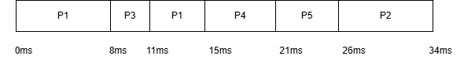

(the time in the parentheses show the remaining times in ms)

t = 0ms:
ready queue: P1 (12)
CPU goes to: P1

t = 5ms:
ready queue: P1(7), P2 (8)
CPU goes to: P1

t = 8ms:
ready queue: P2 (8), P3 (3), P1 (4) (preempted)
CPU goes to: P3

t = 11ms:
ready queue: P1 (4), P2 (8)
CPU goes to: P1

t = 15ms:
ready queue: P2 (8), P4 (6)
CPU goes to: P4

t = 20ms:
ready queue: P2 (8), P4 (1), P5 (5)
CPU goes to: P4

t = 21ms:
ready queue: P2 (8), P5 (5)
CPU goes to: P5

t = 26ms:
ready queue: P2 (8)
CPU goes to: P2

t = 34ms:
ready queue: — (empty)
CPU goes to: —
Program finishes.

Completion Times:
P1: 15ms
P2: 34ms
P3: 11ms
P4: 21ms
P5: 26ms

Turnaround Time:
P1: 15 – 0 = 15ms
P2: 34 – 5 = 29ms
P3: 11 – 8 = 3ms
P4: 21 – 15 = 6ms
P5: 26 – 20 = 6ms

Mean Turnaround Time:
(15ms + 29ms + 3ms + 6ms + 6ms) / 5 = 11.8 ms

iv) Multiple Queue Scheduling
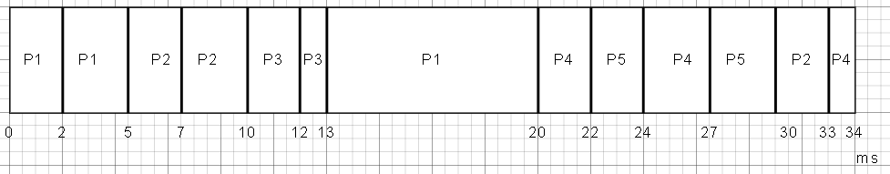

Process | Completion time(ms) | Turnaround time(ms)
P1 | 20 | 20 – 0 = 20
P2 | 33 | 33 – 5 = 28
P3 | 13 | 13 – 8 = 5
P4 | 34 | 34 – 15 = 19
P5 | 30 | 30 – 20 = 10

Mean Turnaround time = ( 20 + 28 + 5 + 19 + 10) / 5 = 16.4 ms

b.
bi) FCFS with I/O
Assumptions made; new process arriving in queue is placed of the process that is waiting for I/O. another assumption is that a process that is completed does not invoke I/O.
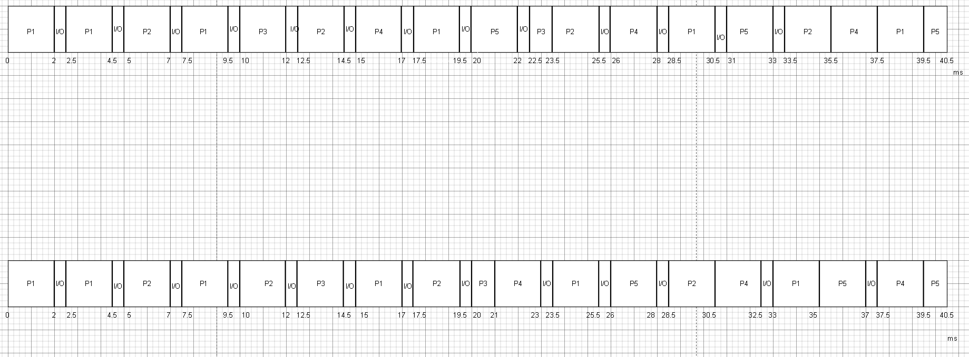

Process | Completion time(ms) | Turnaround time(ms)
P1 | 35 | 35 – 0 = 35
P2 | 30.5 | 30.5 – 5 = 25.5
P3 | 21 | 21 – 8 = 13
P4 | 39.5 | 39.5 – 15 = 24.5
P5 | 40.5 | 40.5 – 20 = 20.5

Mean turnaround time = (35 + 25.5 + 13 + 24.5 + 20.5)/5 = 23.7ms

ii) Round Robin (time slice of 4 ms) with I/O

Note: The labels (CPU idle, P1 goes to I/O, etc.) in the Gantt diagram are for clarification only.

Assumption: At t=5, when P1 returns from I/O and P2 enters the ready queue, P1 enters the ready queue before P2 and then FCFS follows.

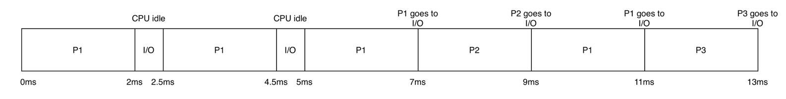
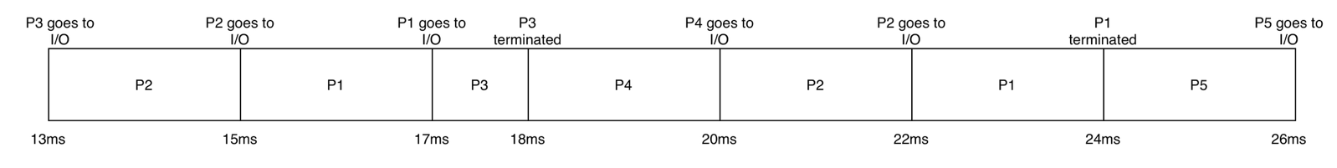
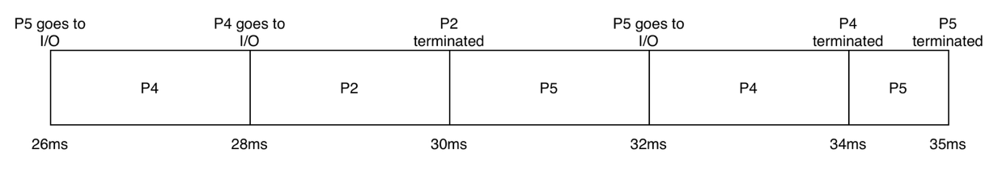

Completion Times:
P1: 24ms
P2: 30ms
P3: 18ms
P4: 34ms
P5: 35ms

Turnaround Time:
P1: 24 – 0 = 24ms
P2: 30 – 5 = 25ms
P3: 18 – 8 = 10ms
P4: 34 – 15 = 19ms
P5: 35 – 20 = 15ms

Mean Turnaround Time:
(24ms + 25ms + 10ms + 19ms + 15ms) / 5 = 18.6 ms

iii) Shortest Job First with preemption

Note: The labels (CPU idle, P1 goes to I/O, etc.) in the Gantt diagram are for clarification only.
Assumption 1: At t=5, when P1 returns from I/O and P2 enters the ready queue, P1 enters the ready queue before P2 and then FCFS follows.

Assumption 2: The processes (P1, P2, and P4) complete their final CPU burst exactly at 2 ms (17.5ms for P1, 24ms for P4, and 36ms for P2), so it terminates without issuing any further I/O requests.

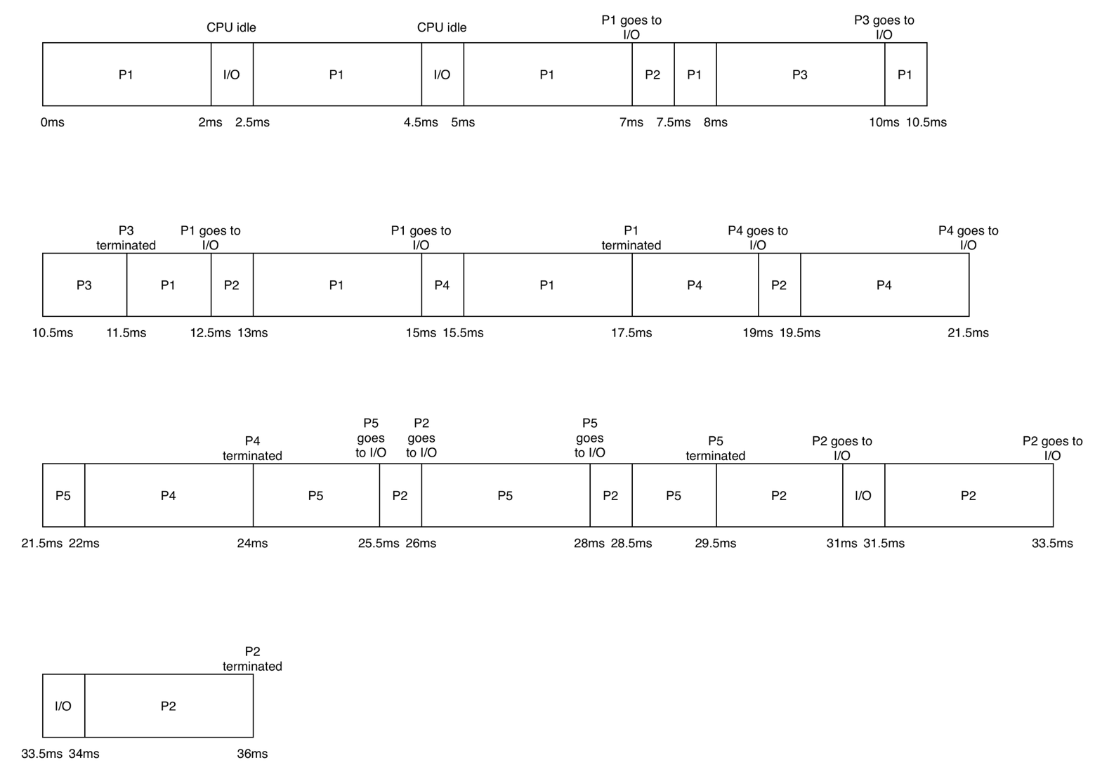

Completion Times:
P1: 17.5ms
P2: 36ms
P3: 11.5ms
P4: 24ms
P5: 29.5ms

Turnaround Time:
P1: 17.5 – 0 = 17.5ms
P2: 36 – 5 = 31ms
P3: 11.5 – 8 = 3.5ms
P4: 24 – 15 = 9ms
P5: 29.5 – 20 = 9.5ms

Mean Turnaround Time:
(17.5ms + 31ms + 3.5ms + 9ms + 9.5ms) / 5 = 14.1ms

iv) Multiple Queue Scheduling with I/O
Assumption made: since processes are interrupted in the mid-priority queue by the I/O before they use their allocated time quantum. The processes do not get demoted to low priority queue and stay in the mid-priority queue.
Process | Completion time(ms) | Turnaround time(ms)
P1 | 39.5 | 39.5 – 0 = 39.5
P2 | 35.5 | 35.5 – 5 = 30.5
P3 | 23.5 | 23.5 – 8 =25.5
P4 | 37.5 | 37.5 – 15 = 17.5
P5 | 40.5 | 40.5 – 20 = 20.5

Mean turnaround time = (39.5 + 30.5 + 25.5 + 17.5 + 20.5) /5 = 26.7ms

C 1 i) First Fit
Job No. | Allocated block  position | Internal fragmentation of allocated block(KB)
J1 | 2 | 340-140=200
J2 | 1 | 85 – 82 = 3
J3 | 8 | 280 – 275 = 5
J4 | 4 | 195 – 65 = 130
J5 | None | None

Total internal fragmentation = 200 + 3 + 5 + 130 = 338KB
Total external fragmentation = 28 + 55 + 160 + 75 = 318KB
ii)Best Fit
Job No. | Allocated hole position | Internal fragmentation of allocated hole(KB)
J1 | 6 | 160 – 140 = 20
J2 | 1 | 85 – 83 = 3
J3 | 8 | 280 – 275 = 5
J4 | 7 | 75 – 65 = 10
J5 | 4 | 195 – 190 = 5

Total internal fragmentation = 20 + 3 + 5 + 10 + 5 = 43KB
Total external fragmentation = 43 + 340 + 28 + 55 = 423KB

iii)Worst Fit
Job No. | Allocated block | Internal fragmentation of allocated block(KB)
J1 | 2 | 340 – 140 = 200
J2 | 8 | 280 – 82 = 198
J3 | None
J4 | 4 | 195 – 65 = 130
J5 | None

Total internal fragmentation = 200 + 198 + 130 = 528KB
Total external fragmentation = 85 + 28 + 55 + 160 + 75 = 403KB
C2)
First fit has the lowest external fragmentation of the three algorithms and is suitable for a system with mixed workload sizes as it has good memory utilization efficiency by being able to allocate 80% of the jobs a hole.
Best has the lowest internal fragmentation and is suitable for a system with frequent small allocations as it managed to allocate all 5 job a hole.
Worst Fit has the highest internal fragmentation and did not manage to allocate Job number 3 and 5 a hole.

Part II – Concurrent Processes in Unix

1.
Fork system call:
When a UNIX process wants to create another process, it does so through the fork system
call. Every process in UNIX is identified by a unique integer called a process identifier, or
PID. When fork is called, the operating system makes a new process that is an exact copy
of the calling process. This new process is known as the child, and the original becomes
the parent. The child process inherits various attributes from the parent, including
privileges, scheduling properties, and open files. Because the child begins as a copy of the
parent’s address space, the two can communicate easily if needed.

After fork executes, both the parent and the child continue running the same program at
the instruction immediately following the system call. The key difference lies in the return
value. For the child process, fork returns zero; for the parent, it returns the process
identifier of the child. This allows each process to determine its role and proceed
accordingly.

If no other system calls are made afterward, both processes continue as separate and
concurrent copies of the same program. Although they share the same code, each process
has its own copy of all data. A change made by one process does not affect the other. The
parent may continue executing in parallel with its child, or it may choose to wait until the
child finishes before resuming.

Through this mechanism, UNIX provides a simple yet powerful way to create new
processes. A single call to fork can duplicate an existing process so that two independent processes continue execution side by side from the same point in the program.

Part 2 Question 2
exec() is a system call that replaces the code, data, heap and stack segments of a running process with a new program. The new program takes over starting its execution with its own main() function. The exec() does not return to calling context, it either eradicated the current running process and starts a new program or returns and error if it fails and the original process continues running.

